Instructions to connect wireless at home

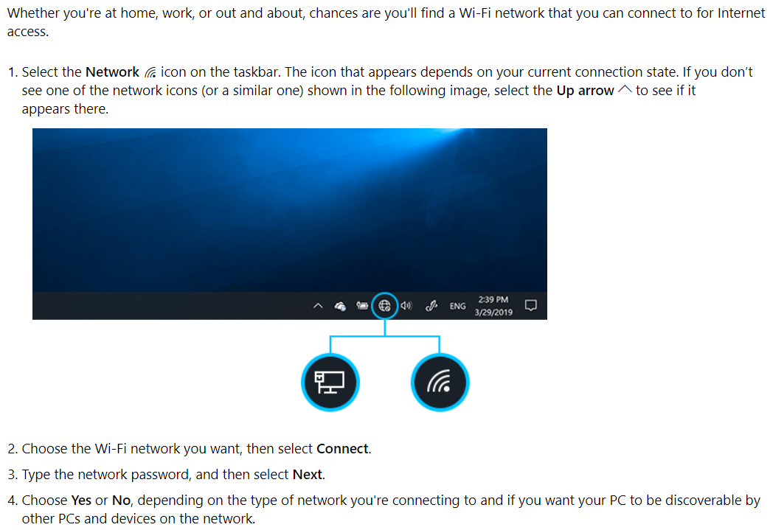

After you connect to your network at home you will probably receive a message prompting you that your desktop is not available. Click Cancel on any warnings you receive when trying to save work. You will need to save any work to C:\users\YourName\documents.

We prefer that you save things to the cloud in google docs. Much easier and accessible from anywhere. You can also save inherently to onedrive which is automatically mapped through our being a microsoft school.

Adobe software can be downloaded and installed using creative cloud at https://creative.adobe.com. Sign in and download and install any adobe software needed to complete assignments. Also, save your documents to either adobe cloud or google cloud.

You might find that downloading and installing google stream will enhance your online educational experience by allowing you to save directly to google cloud. https://google.com/drive/download download the file stream and install on your computer then you can sync your files with the cloud. There will be some setup that you will need to step through.

Troubleshooting connections
Make sure you are putting in your home network password correctly.
If you have issues with the home network or cannot connect, you can go to the school parking lot and sit in the first 2 parking rows. You will be able to connect to mtchs5 with the password of Dragonsrule

Other issues that come up.
If you can connect but are possibly having issues getting to your files. Hopefully you had saved them on google drive or onedrive. If you saved them on the network drive then please send in a help desk ticket and we will send you your files in a zip file so you can pull them out and put them in google drive. Help desk can be found at https://mtchs.on.spiceworks.com/portal. Click on the link and tell us your issue.

We will be checking our ticketing system between the hours of 8:00 am and 3:00 pm. Any tickets outside these hours will be settled the next day in a timely manner.

